**Methodological note: Climate change exposure index**

The climate change risk index used in this report considers hazards (changes in climate over an area) and exposure (population living in the area). The vulnerability domain, or capacity for adaptation, that completes a holistic climate risk evaluation [1] is considered as the socioeconomic risk index. The aim of the climate index is to quantify the projected future change in risk due to climate change, as opposed to current climate risk. Thus, if for example, the entire population of a certain country is subjected to 200 km/h hurricane wind in the present and in the future the hurricane wind remains the same for the whole country, the incremental risk due to climate change will be zero, because that risk is present even today when climate change’s most significant impacts have not yet emerged. Additionally, the index does not consider all possible extreme meteorological impacts from climate change, so countries with an apparent low index value may still be highly exposed to other phenomena not considered herein, such as wildfires.

The future climate in inherently uncertain and care must be taken to consider that all values are projections and not predictions [2]. For this index, an inertial, or middle-of-the-road scenario is used, named by the IPCC as the Shared Socioeconomic Pathway SPP2-4.5 [3]. This scenario is consistent with approximately 2°C of heating by 2050 and 3°C by 2100. All impacts are calculated to the years 2040-60 and the current period is considered as 1995-2014. For sea-level rise, the current period is 2000 and the future period is 2060.

The objectives established in the development of the index are to consider exposure to climate change in a range of extreme weather events, to estimate the change in exposed due to climate change and an evolving population, to strive for comparability between different exposure categories and within countries with a wide range of populations and climates, and to make a simple enough index that can easily be traced back to the number of affected inhabitants.

Five risk categories have been selected: Hurricanes, extreme precipitation, drought, extreme temperatures, and sea level rise. For each category a specific measure is selected. The climate variables used are, respectively: 100-year return period hurricane wind; 20-year average annual 1-day maximum rainfall, measured as a percentage of average total annual rainfall; 20-year average 12-month SPEI (Standardized Precipitation Evapotranspiration Index; measuring the anomaly of surface moisture in the past 12 months; numbers below zero indicate drought and viceversa [4]); 20-year average annual number of days with a mean temperature above 35°C; and the 100-year return period coastal floodplain.

Present and future population, precipitation, drought, and temperature data have been obtained from the World Bank’s Climate Change Knowledge Portal [5] in the form of a 0.25°x0.25° global gridded dataset derived from IPCC’s CMIP climate model runs. Population projections consider international and internal rural-migration due to existing processes, but not the expected climate migration. Hurricane data comes from the UNDDR Global Assessment Report 2015 [6]. It must be considered that impacts of climate change on hurricanes are still poorly understood [7]. A general estimate is a 5% to 10% increase in storm intensity in a 2°C warmer world [8]; this factor (10%) has been used globally to produce a future wind speed dataset for this index. Sea-level rise data comes from the paper by Neumann et al. [9] and is the only data not available in a spatially explicit gridded form.

For each risk category the index is constructed as follows: in every grid cell the variable value of the historical data is multiplied by the historical percentage of national population to obtain a value measured in inhabitants-variable (e.g. inhabitants-wind speed). The same operation is repeated for future values and next the subtraction of future data minus historical data is calculated. This methodology estimates the change in exposed population along a wide range of base values, allowing the comparison between regions with different climates. For example, a resulting value in the extreme temperature category of 100 % inhabitants-days could represent a change of 10% of the population exposed to an increase from 10 days above 35°C to 20 days in 2050 (10% inhabitants × 10 days = 100% inhabitants-days), or it could be 10% of the population exposed to a change of 20 to 25 days in a mild climate in a portion of the country and another 5% of the population exposed to a change of 100 to 110 days in a warmer region (10% inhabitants × 5 days + 5% inhabitants × 10 days = 100 inhabitants-days ). Thus, the methodology can take into consideration and compare the change in climate in both colder and warmer regions of the world.

The value for each cell within a certain country is added to obtain a total number. The resulting value can be zero, if the same amount of population is exposed to the same climate in present and future; lower than zero, if the exposed population is reduced (e.g. for sea level rise if there is already a depopulation process of the coast due to rural-urban migration), or larger than zero, if the share of exposed population increases. Any negative change in exposure has been set as a value of 0, since the exposure index will be higher as the population of countries become more exposed to the impacts of climate change. The last step to obtain the index for a given category is to calculate the rank percentile (a generalization of the classical statistical percentile that allows for repeated values) to obtain a value between 0 and 10.

The resulting index for each category therefore is higher the larger the population increase and the change in climate for a given country. However, is does not directly represents a given population number. Anyhow, the number of inhabitants affected can be obtained from the index by setting specific thresholds for each category, which have been selected as: Hurricanes, areas expected to receive landfall of a hurricane of category 4 or higher in a 100-year return period; Extreme rainfall, areas where the 20-year average of annual maximum 1-day rainfall is at least 10% of the total annual rainfall; Drought, regions where the 20-year average of the 12-month SPEI is below -0.15; Extreme temperature, areas with more than 12 weeks of daily temperatures above 35°C; and Sea level rise, the 100-year return period coastal floodplain.

Each country has a value for the 5 climate risk categories and an additional value that integrates the entire climate change risk, given as an average of the five categories and normalized to have a value of 0 for the least exposed country and 10 for the most exposed one.

Figure 1 represents the modelled yearly number of days above 35°C for the period 2040-2060 in a middle-of-the-road SSP2-4.5 climate change scenario, while figure 2 represents the Extreme temperature risk index. The 10 countries most exposed due to climate change are Bahrain (index value: 10), Cambodia (9.9), Burkina Faso (9.9), Senegal (9.8), Mali (9.7), Guinea-Bissau (9.7), Namibia (9.6), Thailand (9.5), and Egypt (9.4).

Figure 3 depicts the integrated climate risk index, where the countries with a largest value (ranging from 0 to 10) are Japan (index value: 10, highly exposed to sea level rise, extreme rainfall and hurricanes), Greece (9.9, exposed to sea level rise, drought, extreme temperature, and extreme rainfall), Bahrain (9.8, sea level rise, extreme temperature and extreme rainfall), Somalia (9.6, sea level rise, extreme temperature, extreme rainfall), Kuwait (9.2, sea level-rise, extreme temperature, extreme rainfall), Montserrat (9.0, sea level rise, drought, hurricanes), China (9.0, sea level rise extreme temperature, extreme rainfall), Thailand (9.0, sea level rise, extreme temperature), Qatar (8.9, sea level rise, extreme temperature, extreme rainfall), and Anguilla (8.7, sea level rise, drought, hurricanes). Most of the countries in this list present large socioeconomic vulnerabilities with hinder their population’s capacity to adapt to a changing climate and underline their need to work swiftly towards a just climate transition. Other countries, such as Japan, might rank high in exposure to sea level rise, but since the index doesn’t consider adaptation measures, richer countries will probably not be as exposed in the future as indicated by these values.

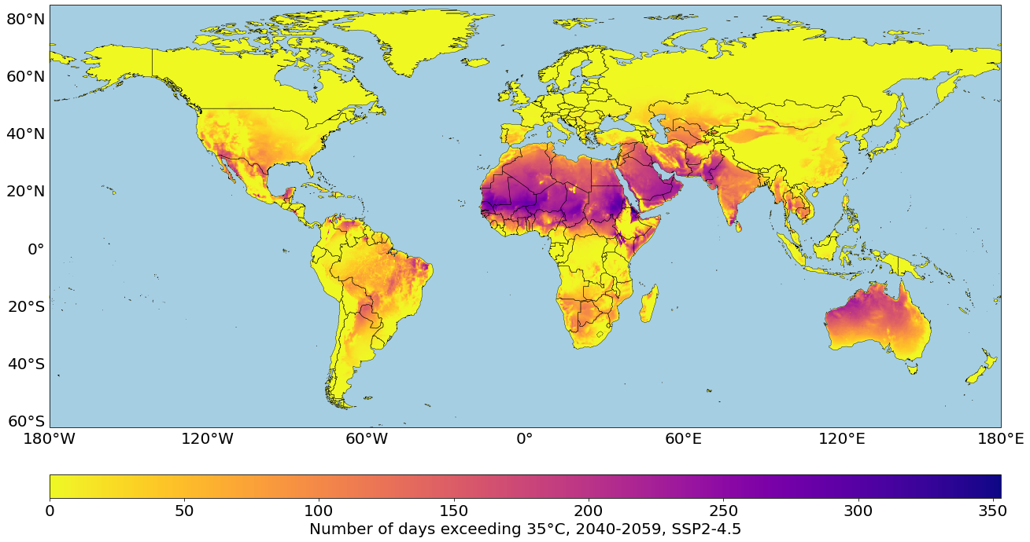

Figure 1. Number of days exceeding 35°C in 2050 under the SSP2-4.5 climate scenario

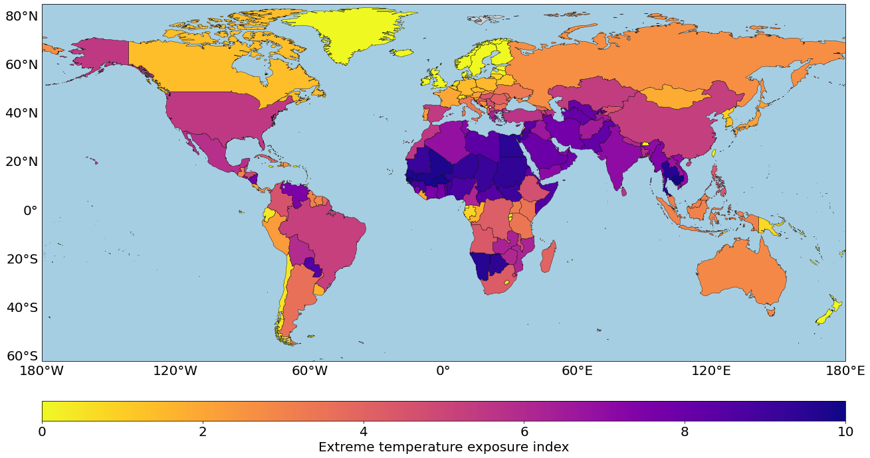

Figure 2. Extreme temperature exposure index. The possible values range from 0 to 10

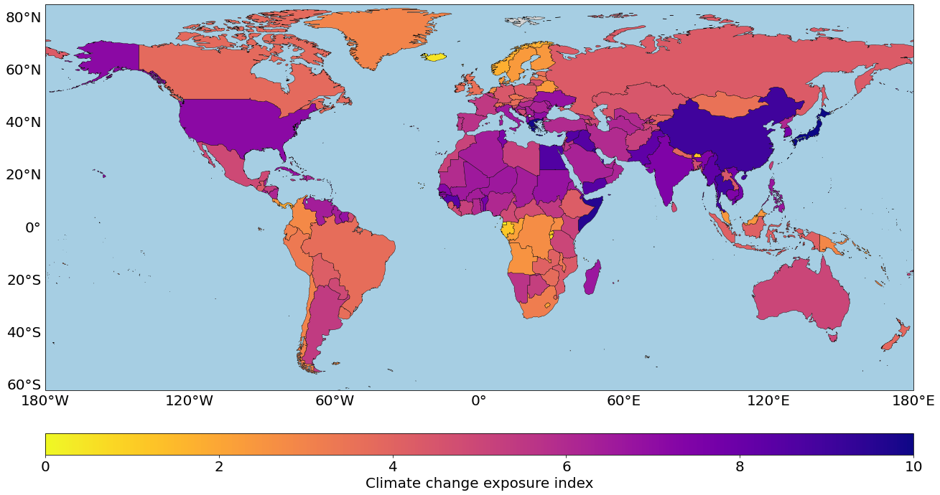

Figure 3. Climate change exposure index. The possible values range from 0 to 10

**References**

1. Intergovernmental Panel on Climate Change. Glossary, Acronyms and Chemical Symbols. In: Climate Change 2014: Mitigation of Climate Change: Working Group III Contribution to the IPCC Fifth Assessment Report. Cambridge University Press; 2015:1249-1280. <https://doi.org/10.1017/CBO9781107415416.023>
2. Gay, C., Estrada, F. Objective probabilities about future climate are a matter of opinion. Climatic Change 99, 27–46 (2010). <https://doi.org/10.1007/s10584-009-9681-4>
3. Riahi, K., van Vuuren, D. P., Kriegler, E., Edmonds, J., O’Neill, B. C., Fujimori, S., Bauer, N., Calvin, K., Dellink, R., Fricko, O., Lutz, W., Popp, A., Cuaresma, J. C., Kc, S., Leimbach, M., Jiang, L., Kram, T., Rao, S., Emmerling, J., ... Tavoni, M. (2017). The Shared Socioeconomic Pathways and their energy, land use, and greenhouse gas emissions implications: An overview. Global Environmental Change, 42, 153–168. <https://doi.org/10.1016/j.gloenvcha.2016.05.009>
4. Vicente-Serrano, S. M., Beguería, S., & López-Moreno, J. I. (2010). A Multiscalar Drought Index Sensitive to Global Warming: The Standardized Precipitation Evapotranspiration Index. Journal of Climate, 23(7), 1696-1718. https://doi.org/10.1175/2009JCLI2909.1
5. World Bank, Climate Change Knowledge Portal (2024). URL: <https://climateknowledgeportal.worldbank.org/>. Date Accessed: 9 July 2024.
6. United Nations Office for Disaster Risk Reduction (UNDRR) (2015). Global Assessment Report on Disaster Risk Reduction 2015: Dataset. <https://data.humdata.org/organization/5cc66954-20e3-4bbf-8451-3a15bea4e320>
7. Knutson, T. R., Chung, M. V., Vecchi, G., Sun, J., Hsieh, T-L. and Smith, A. J. P., 2021: ScienceBrief Review: Climate change is probably increasing the intensity of tropical cyclones. In: Critical Issues in Climate Change Science, edited by: Corinne Le Quéré, Peter Liss & Piers Forster. <https://doi.org/10.5281/zenodo.4570334>
8. Knutson, T., and Coauthors, 2020: Tropical Cyclones and Climate Change Assessment: Part II: Projected Response to Anthropogenic Warming. Bull. Amer. Meteor. Soc., 101, E303–E322, <https://doi.org/10.1175/BAMS-D-18-0194.1>.
9. Neumann, B., Vafeidis, A. T., Zimmermann, J., & Nicholls, R. J. (2015). Future Coastal Population Growth and Exposure to Sea-Level Rise and Coastal Flooding—A Global Assessment. PLOS ONE, 10(3), e0118571. <https://doi.org/10.1371/journal.pone.0118571>

**Annex A: Climate exposure categories**

Figure A.1 presents 100-year wind speed in 2050 in a middle-of-the-road SSP2-4.5 climate change scenario, while figure A.2 represents the Hurricane risk index. The 10 countries with the largest increase in exposure are mostly islands located in the Caribbean and in Eastern Asia: Chinese Taipei (index value: 10), Northern Mariana Islands (9.9), Guam (9.8), Mauritius (9.6), Philippines (9.5), Réunion (9.4), Japan (9.3), Hong Kong (9.14), Macao (9.0), and the Bahamas (8.9).

The 10 countries with the largest increase in extreme rainfall exposure are Qatar (index value: 10), United Arab Emirates (9.9), Saudi Arabia (9.9), Bahrain (9.9), Kuwait (9.8), Oman (9.7), Iraq (9.7), Djibouti (9.6), Niger (9.6), and Yemen (9.5) (Figures A.3 and A.4). This countries are all located in sub-Saharan Africa and in the Arab Peninsula, where the arid climates already bring few wet days a year. The 10 countries with the largest increases in exposure to drought are: Trinidad and Tobago (index value: 10), Guyana (9.9), Saint Vincent and the Grenadines (9.8), Martinique (9.8), French Guiana (9.67), Saint Lucia (9.6), Dominica (9.5), Algeria (9.4), Venezuela (9.3), and Suriname (9.3) (Figures A.5 and A.6). Regarding the increase in exposure to sea level rise, the 10 most affected countries are: Monaco (10), Kuwait (9.9), Macao (9.8), Aruba (9.8), Viet Nam (9.7), Montserrat (9.6), Thailand (9.5), Wallis and Futuna (9.4), Gibraltar (9.3), and Anguilla (9.2) (Figure A.7).

Figures A.8. to A.11. show the regions where the extreme value thresholds have been exceeded for each climate category during the period 2040-2059 in a SSP2-4.5 scenario.

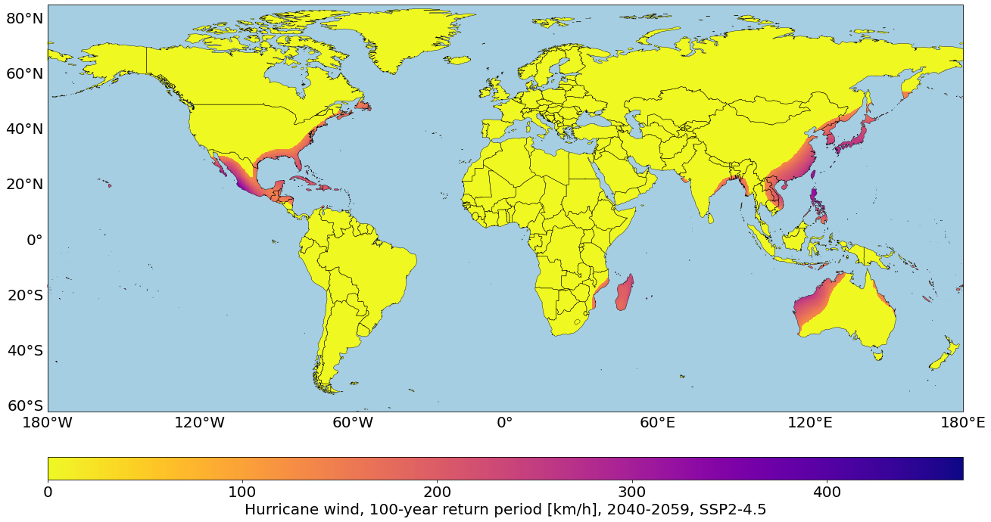

Figure A.1. 100-year Hurricane wind speeds in 2050 in the SSP2-4.5 climate scenario

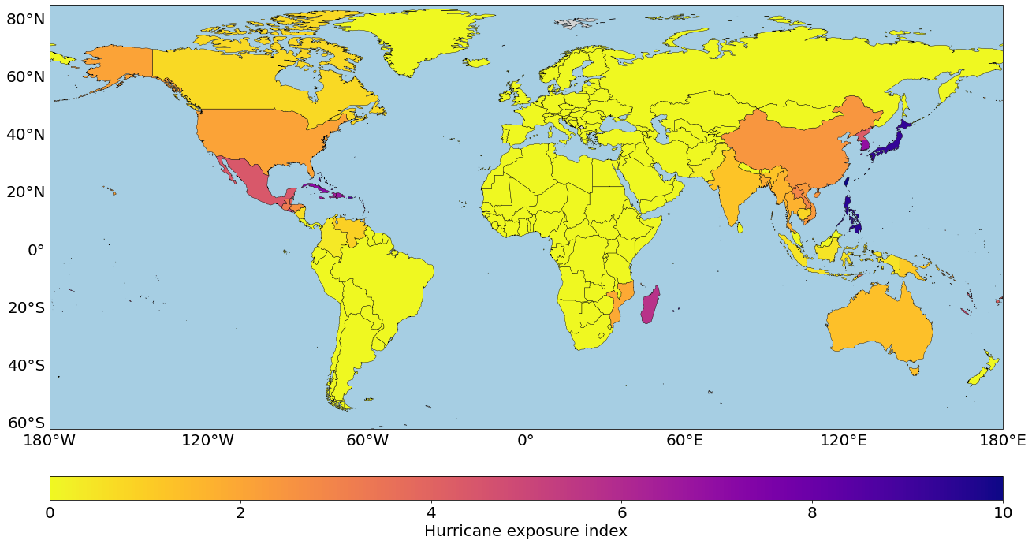

Figure A.2. Hurricane risk index. The possible values range from 0 to 10

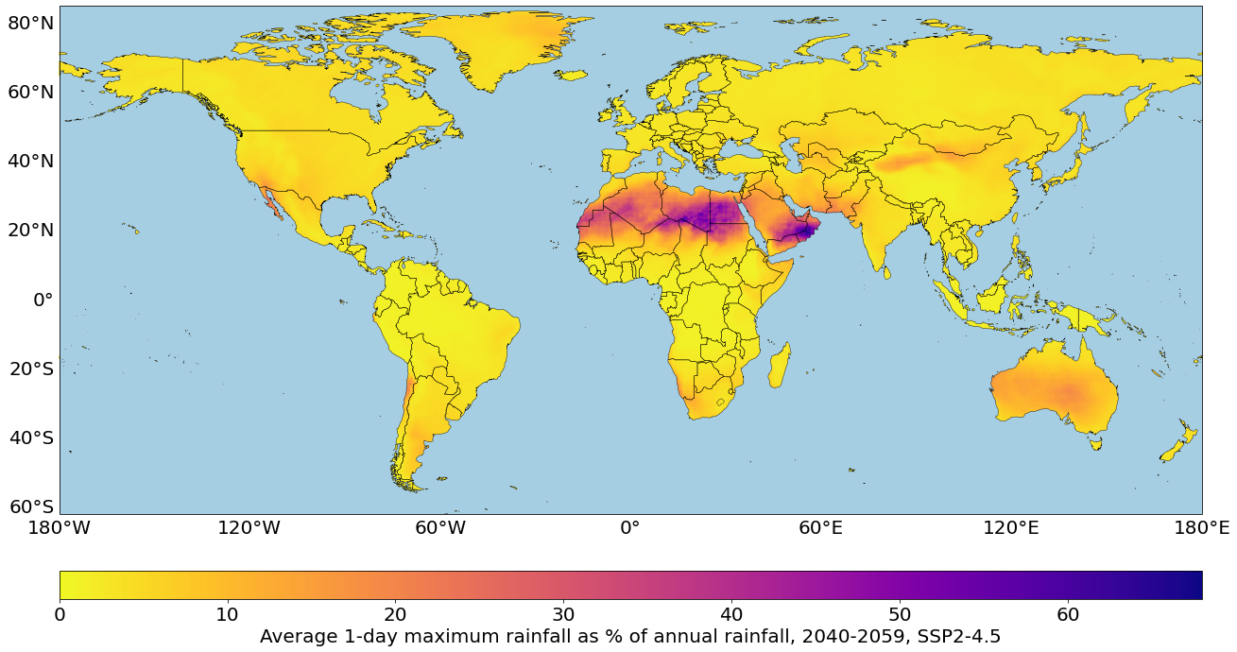

Figure A.3. Average maximum rainfall in 1 day in 2050 in the SSP2-4.5 climate scenario

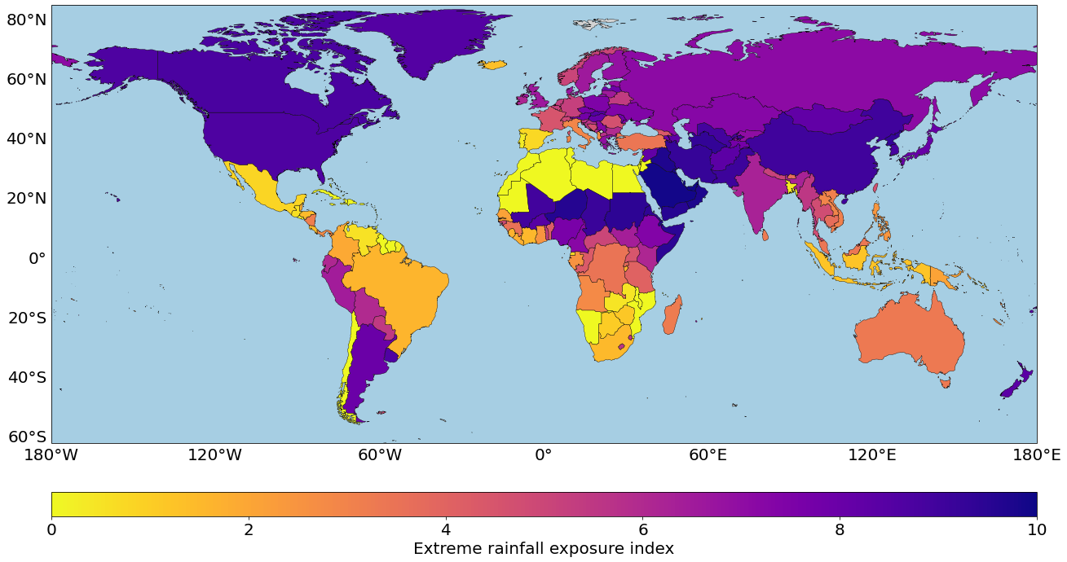

Figure A.4. Extreme rainfall risk index. The possible values range from 0 to 10

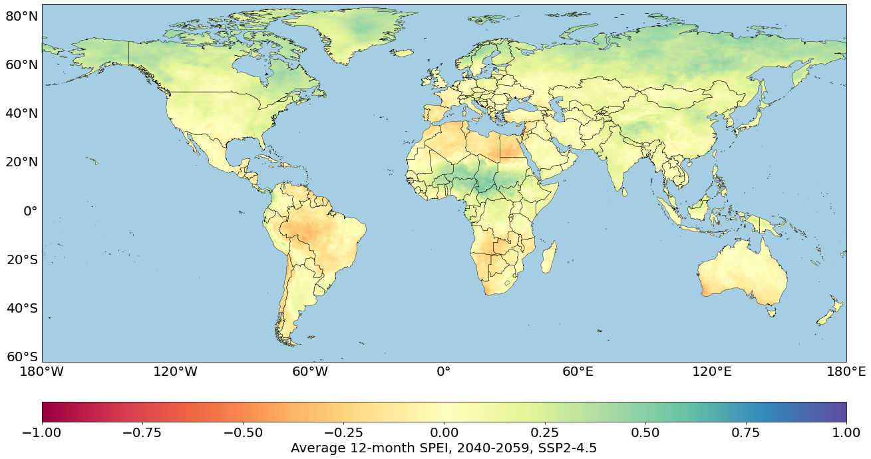

Figure A.5. Average 12-month SPEI in 2050 in the SSP2-4.5 climate scenario

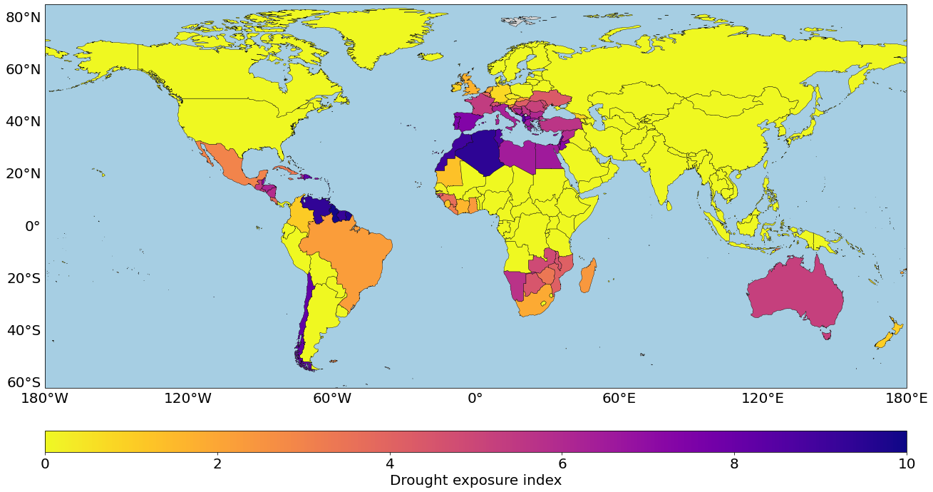

Figure A.6. Drought risk index. The possible values range from 0 to 10

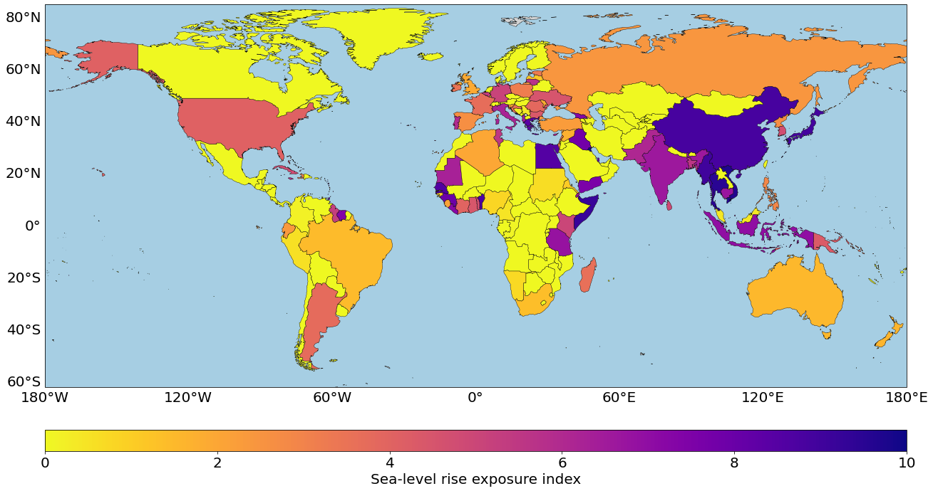

Figure A.7. Sea-level rise risk index. The possible values range from 0 to 10

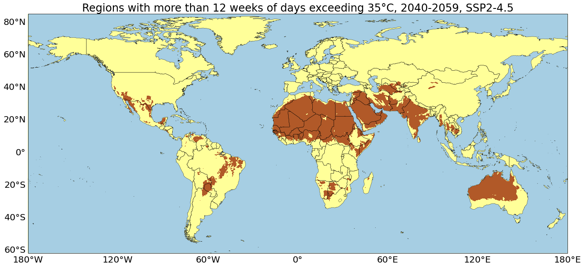

Figure A.8. Regions with more than 12 weeks of days exceeding 35°C in 2050 in the SSP2-4.5 climate scenario

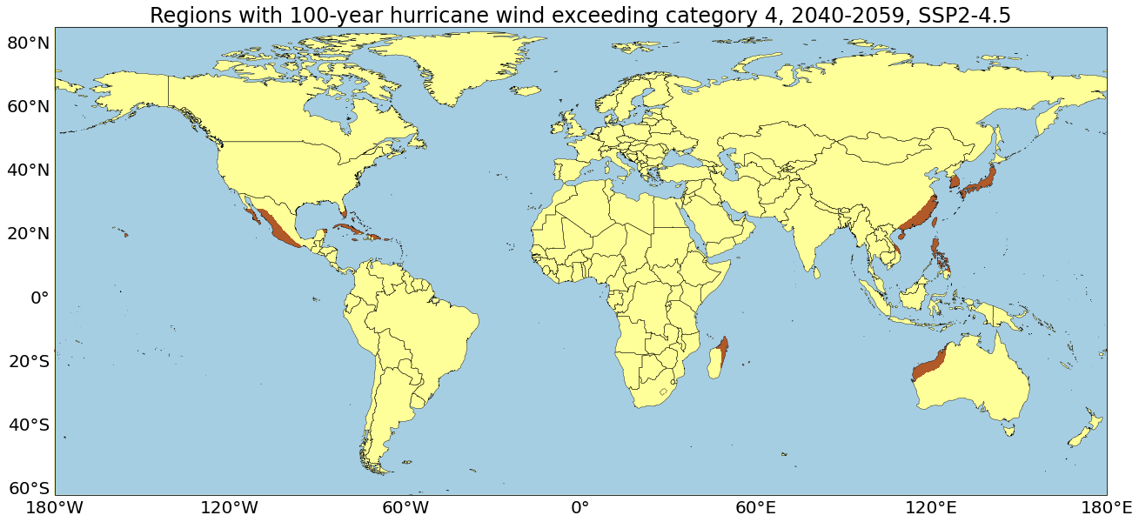

Figure A.9. Regions with 100-year hurricane winds above category 4 in 2050 in the SSP2-4.5 climate scenario

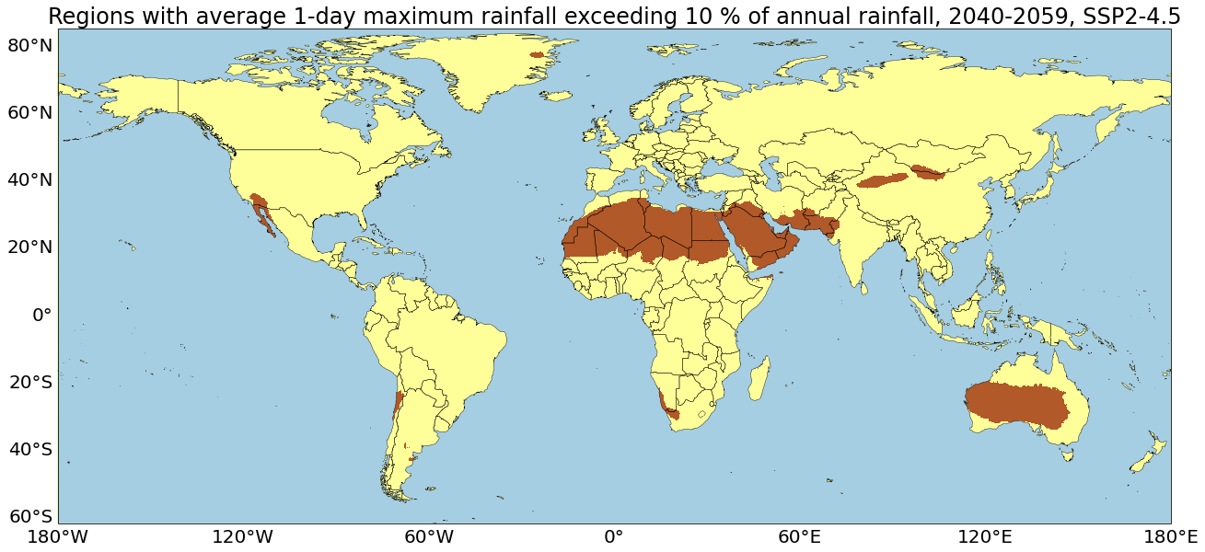

Figure A.10. Regions with 1-day maximum rainfall exceeding 10% of annual rainfall in 2050 in the SSP2-4.5 climate scenario

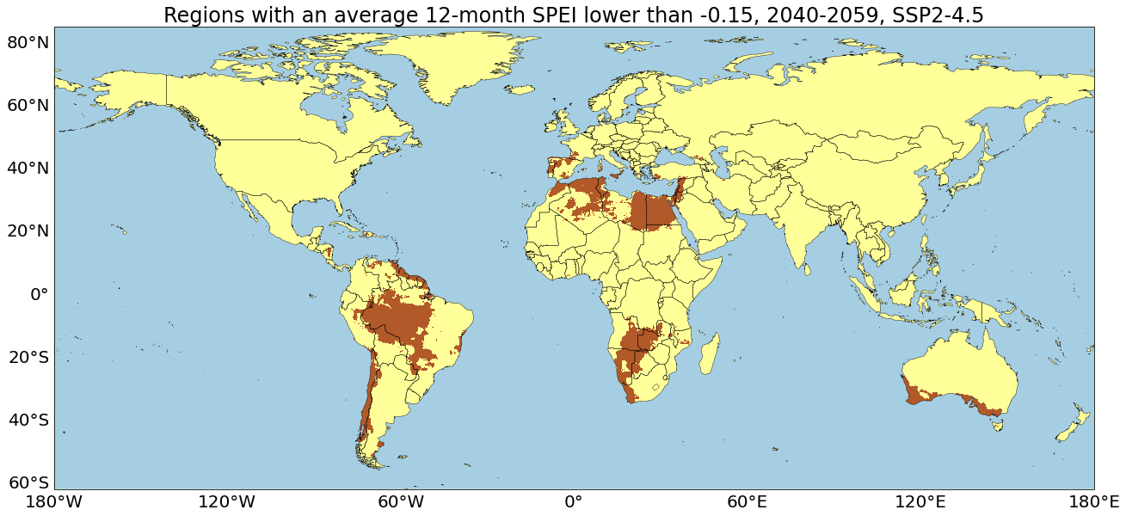

Figure A.11. Regions an average 12-month SPEI below -0.15 in 2050 in the SSP2-4.5 climate scenario

**Annex B: Index and population values for a given country**

As an example, the exposure values for China are shown:

* Average population (1995-2014): 1,297,930,752
* Average population (2040-2059): 1,256,397,952
* Climate change exposure index [0-10]: 9.0
* Sea level rise exposure index [0-10]: 8.9
* Drought exposure index [0-10]: 0.0
* Extreme temperature exposure index [0-10]: 5.3
* Extreme rainfall exposure index [0-10]: 9.0
* Hurricane exposure index [0-10]: 2.4
* Population in 100-year return period coastal flood plain (2000): 55,983,689
* % Population in 100-year return period flood plain (2000)[1]: 4.4%
* Population in 100-year return period flood plain (2060): 86,219,932
* % Population in 100-year return period flood plain (2060)1: 7.1%
* Exposed population to an average 12-month SPEI below -0.2 (1995-2014): 1,285,404,288
* % Exposed population to an average 12-month SPEI below -0.2 (1995-2014): 99.0%
* Exposed population to average 12-month SPEI below -0.2 (2040-2059): 2,472
* % Exposed population to an average 12-month SPEI below -0.2 (2040-2059): 0.0%
* Exposed population to more than 12 weeks of days above 35°C (1995-2014): 25,454
* % Exposed population to more than 12 weeks of days above 35°C (1995-2014): 0.0%
* Exposed population to more than 12 weeks of days above 35°C (2040-2059): 125,691
* % Exposed population to more than 8 weeks of days above 40°C (2040-2059): 0.0%
* Exposed population to average 1-day maximum rainfall above 10% of average annual rainfall (1995-2014): 1,555,817
* % Exposed population to average 1-day maximum rainfall above 5% of average annual rainfall (1995-2014): 0.1%
* Exposed population to average 1-day maximum rainfall above 5% of average annual rainfall (2040-2059): 1,654,520
* % Exposed population to average 1-day maximum rainfall above 5% of average annual rainfall (2040-2059): 0.1%
* Exposed population to 100-year return period hurricane winds above category 4 (1995-2014): 149,305,600
* % Exposed population to 100-year return period hurricane winds above category 4 (1995-2014): 11.5%
* Exposed population to 100-year return period hurricane winds above category 4 (2040-2059): 250,388,816
* % Exposed population to 100-year return period hurricane winds above category 4 (2040-2059): 1.1%
* Increase in % exposed population to 100-year return period hurricane winds above category 4 (2005-2050)1: 19.9%

1. May not correspond exactly to a percentage calculated with the total population values above; the reference periods are slightly different and the data source differs.